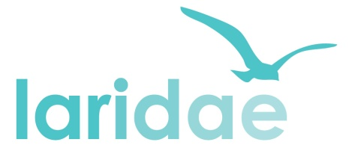
PERSON SPECIFICATION

Post Title: Information and Project Officer enquiry focus
Essential | Desirable | Assess  by
Knowledge
- A broad understanding of the importance of information, advice and advocacy in enabling people to:  - get the best from health and care services they may require  - enjoy independence and quality of life  - Interest in and knowledge of health and / or social care services | - A working knowledge and understanding of the following in Liverpool:  - information, advice and advocacy services  - health, social care and community services | A, I & CS
Experience
Dealing with stressed members of the public who are not necessarily sure of what support they need or what might be available  Demonstrate the ability to deal with highly confidential / contentious information in a discreet and appropriate manner | Using or providing information, advice or advocacy either professionally or informally | A, I & CS
Skills and competencies
We are looking for someone who has good organisational skills  These include:  - Being able to determine priorities, manage time effectively and work to competing deadlines  - The ability to communicate clearly, both verbally and in writing to a wide range of people  - The ability to communicate our work to enquirers and other agencies  We are looking for someone who is competent in using IT  This includes:  Familiarity with using a variety of programmes, including Word, Excel, and Access  Accessing and updating enquirer records, searching and maintaining databases of services  The ability to learn how to use Healthwatch specific data and IT systems  Able to use the Live Well directory and other reliable sources of information online |  | A, I & CS  A & I
Personal Attributes
Is a good listener, with a supportive and patient telephone manner  Has sensitivity, insight and an understanding of the different needs and wishes of individuals  Enjoys communicating with people and learning from the interaction  Has the capacity to use initiative independently, whilst being able to work as part of a team  Can think widely and flexibly to suggest options for enquiries  Has a willingness to work flexibly in a wide-ranging service  Has the ability to motivate and enthuse others |  | A & I
Other
We are looking for someone who can demonstrate an understanding of, and a commitment to, the principles of equality and inclusion that inform the work of Liverpool Advocacy Rights Information Development and Equality (LARIDAE)  This involves having:  A firm belief in the equal rights and dignity of all human beings  An understanding of the importance of independent advocacy  An understanding of the barriers and discrimination often experienced by members of our communities which can devalue and exclude them | Have an appreciation of the difficulties that the public may face in accessing services and how to overcome them | A, I & CS
Key to assessment methods; (A) Application form (I) Interview (CS) Case Study.
References will be used to help confirm suitability for the post.

