Liverpool Advocacy Rights Information Development and Equality CIC (Laridae) 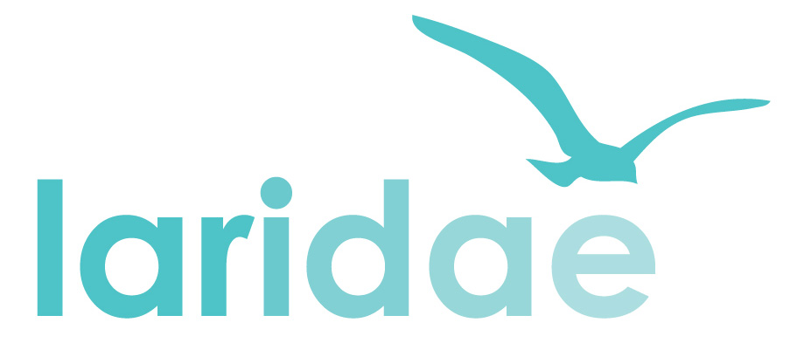

Healthwatch Information and Projects Officer (Engagement)
GUIDANCE ON COMPLETING THE APPLICATION FORM

We will short-list candidates for interview solely on the basis of the information given on the application form. Please do not send CVs or similar as they cannot be considered.

To ensure confidentiality, your personal details and the Equal Opportunities Monitoring Form will be separated from your application. Only the application form will be distributed to the short-listing panel.

The closing date for applications by email is midnight Sunday 21st April 2019 (postal or hand-delivered applications must reach us by 5pm on Friday 19th April 2019). Applications received after this date will not be considered.

Look carefully at the Person Specification and Job Description. These will tell you what the job involves and the range of skills that are required. A good application should provide evidence that you meet the essential criteria through clear examples. Please keep your response to the question about competencies to no more than 2 sides of A4 paper. Applications which exceed this will not be considered.

SHORT-LISTING AND INTERVIEWS
To select the short-list of candidates to interview, we will look for evidence on the application forms that each of the essential points on the Person Specification has been met. Short-listed applicants will be invited to interview.

Please note that due to the expected high number of applicants, we are unable contact individuals who have not been short-listed. If you have not heard from us within ten days of the closing date you can assume that your application has not been successful. We regret that we will not be able to provide feedback to any unsuccessful written applications.

